HLD template - AWS
ORG: Technology

Exported on 2026-02-12 13:57:52

Table of Contents

1 Document Control 4
1.1 Document Identification 4
2 High Level Design 8
2.1 Scope of the document 8
2.2 Document history 8
3 Introduction 9
3.1 Background 9
3.1.1 State of art / Current scenario / AS IS 9
3.1.2 Desired scenario / TO BE 9
4 Project scope 10
4.1 In scope 10
4.2 Out of Scope 10
4.3 Assumptions 10
4.4 Constraints 10
4.5 Dependencies 10
4.6 Project RACI Matrix (Attach RACI Matrix from SOW) 11
4.6.1 Infrastructure and Licenses 11
4.6.2 Professional Services 11
4.6.3 Deployment Activities 12
4.6.4 Acceptance Testing Activities 12
4.6.5 Ongoing Service Activities 12
4.7 Design principles 12
4.8 Naming convention 13
4.8.1 Cloud Naming and Tagging 13
5 Project phases 23
5.1 Phase 1: Design landing basis 23
5.1.1 Decisions and Rationale 23
5.2 Phase 2: Implement landing basis 23
5.2.1 Decisions and Rationale 23
5.3 Phase 3 24
5.4 Phase 4 24
6 NTT DATA Management Zone 25
6.1 Decisions and Rationale 25
6.2 NTT DATA AMZ overview 27
6.2.1 NTT DATA Shared Zones 27
6.2.2 SMZ 27
6.2.3 AMZ 28
6.3 NTT DATA Management Zone architecture 29
6.3.1 Networking design 29
6.3.2 Management VPN 30
6.4 Security Design 33
6.4.1 NTT DATA Access Management 33
6.4.2 Multi-Factor Authentication 34
6.4.3 Decisions and Rationale 35
6.5 NTT DATA Management Tools 35
6.5.1 Logic Monitor 35
6.5.2 ProMonitor 37
6.5.3 Automation 39
6.5.4 Backup 42
6.5.5 Patching 42
6.5.6 Accessibility 42
6.5.7 Terraform & packer 45
7 Customer workload X 46
7.1 Overview 46
7.2 Architecture 46
7.2.1 Topology diagram 46
7.2.2 Networking design 46
7.3 Infrastructure 46
7.4 Application 46
7.5 Security 47
7.5.1 User Management 47
7.5.2 Accessing the platform 47
7.5.3 Software security 47
7.5.4 Infrastructure security 47
7.6 Data classification and management 47
7.7 Backup 47
7.7.1 Backup strategy 47
7.7.2 Backup archiving 48
7.8 Logging 48
7.9 Patching 48
7.9.1 Patching strategy 48
7.10 Monitoring 49
7.11 Quality Acceptance 49
7.12 Application Release (Code) Management 50
7.13 Disaster recovery 50
7.14 Post Implementation Review 50

Document Control

Document Identification

Create  d by | Noé Núñez
Date creation | Oct 24, 2022
Last revision | Aug 26, 2024
Document status | published
Document version | 26

- Document Control
  - Document Identification
- High Level Design
  - Scope of the document
  - Document history
- Introduction
  - Background
    - State of art / Current scenario / AS IS
    - Desired scenario / TO BE
- Project scope
  - In scope
  - Out of Scope
  - Assumptions
  - Constraints
  - Dependencies
  - Project RACI Matrix (Attach RACI Matrix from SOW)
    - Infrastructure and Licenses
    - Professional Services
    - Deployment Activities
    - Acceptance Testing Activities
    - Ongoing Service Activities
  - Design principles
  - Naming convention
    - Cloud Naming and Tagging
      - Cloud Resources naming
      - Cloud Resources Tagging
- Project phases
  - Phase 1: Design landing basis
    - Decisions and Rationale
  - Phase 2: Implement landing basis
    - Decisions and Rationale
  - Phase 3
  - Phase 4
- NTT DATA Management Zone
  - Decisions and Rationale
  - NTT DATA AMZ overview
    - NTT DATA Shared Zones
    - SMZ
    - AMZ
      - AMZ Principles
  - NTT DATA Management Zone architecture
    - Networking design
    - Management VPN
      - VPN requirements
        - IKE Phase 1 (Main Mode) parameters
        - IKE Phase 2 (Quick Mode) parameters
        - Connectivity requirements
        - Solution Assumptions
        - Performance, Capacity and Growth
  - Security Design
    - NTT DATA Access Management
      - PAM
      - Direct access
      - Ports requirements
    - Multi-Factor Authentication
    - Decisions and Rationale
  - NTT DATA Management Tools
    - Logic Monitor
      - Monitoring strategy
      - Network requirements
      - System requirements
      - Permissions requirements
    - ProMonitor
      - Remote ProMonitor Collector Requirements
    - Automation
      - Introduction
      - System and network requirements
      - Core Components
        - SaltStack
          - Network requirements
          - Permissions requirements
        - Ansible
          - System requirements
          - Network requirements
    - Backup
    - Patching
    - Accessibility
      - Connectivity requirements
      - Infrastructure requirements
      - Password rotation requirements
        - Windows
        - Active Directory
        - Linux
        - Network devices and other appliances
    - Terraform & packer
- Customer workload X
  - Overview
  - Architecture
    - Topology diagram
    - Networking design
  - Infrastructure
  - Application
  - Security
    - User Management
    - Accessing the platform
    - Software security
    - Infrastructure security
  - Data classification and management
  - Backup
    - Backup strategy
    - Backup archiving
  - Logging
  - Patching
    - Patching strategy
  - Monitoring
  - Quality Acceptance
  - Application Release (Code) Management
  - Disaster recovery
  - Post Implementation Review

High Level Design

Scope of the document
Contributors, Distribution List and Owner of the document.
Name | C/D/O | Organization | Title

Document history
Version | Date | Issued By | Reason | Status | Reviewed By
0.1
0.2

Introduction

Background

State of art / Current scenario / AS IS
Current situation of the architecture.

Desired scenario / TO BE
After project scenario.

Project scope

In scope
The following key items are in scope for the AWS Platform.
REF# | Scope Item | Priority
IS01 |  | High
IS02 |  | Low

Out of Scope
The following key items have been considered out of scope for this document.
REF# | Scope Item
OS01
OS02

Assumptions
The solution has been developed on the following assumptions.
Ref# | Description
A01
A02

Constraints
The following solution constraints have been identified.
Ref# | Constraint
C01
C02

Dependencies
The solution has dependencies on the following.
Ref# | Dependency
D01
D02

Project RACI Matrix (Attach RACI Matrix from SOW)

RACI Matrix definition
Role | Explanation
Responsible (R) | Performs actions to support the certification of this requirement
Accountable (A) | Responsible for the certification of this requirement
Consulted (C) | May be required to provide information or approval to support compliance
Informed (I) | May request or be provided with information regarding compliance.

Task | NTT DATA | Customer

Infrastructure and Licenses
Task | NTT DATA | Customer

Professional Services
Task | NTT DATA | Customer

Deployment Activities
Task | NTT DATA | Customer

Acceptance Testing Activities

Task | NTT DATA | Customer

Ongoing Service Activities
Task | NTT DATA | Customer

Design principles
The following design criteria will be followed.
Ref# | Principle
P01 | Architecture redesign.  - Deep analysis of each workload will be done to identify improvements points.  - Simplicity and efficiency will be the main rules to follow for the new design.  - Serverless and native cloud services will be used when possible.
P02 | Fresh deployment.  - The whole infrastructure will be redeployed with Terraform.  - Packer will be the tool for AMI management.  - Deployments will be automated and traceable using CI/CD techniques.
P03 | Improved operation.  - NTT DATA Management zone allows us to give a more efficient support.  - Delivery time is highly improved due to several workflow integrations.  - Automation is a must and NTT DATA provides these automation services embedded.
P04 | New monitoring.  - Logic Monitor will be the monitoring solution for the customer platform.  - Logic Monitor provides a high available monitoring service.
P05 | Security by design.  - Amazon Linux 2 secure image will be used.  - NTT DATA Compliance as a Service is available to enforce security practices.  - NTT DATA management zone is fully certified in security standards.
P06 | Redundant VPN.  - A new redundant IPSec VPN needs to be established to connect the NTT DATA management zone.  - Secure access for NTT DATA engineers to access & manage the solution.

Naming convention
A basic part of any architecture design is the choice of name styles and components. Solid naming conventions make designs easier to implement and understand in a collaborative environment. It’s also important that components names enable system operations where filters, scripts, and grouping are often used.
The goals on the naming convention are:
- Consistency
- Clarity
- Meaning
- Be able to follow and “order of operations” type structure.
- Use the same case for all names when possible.

Cloud Naming and Tagging
https://confluence.nttltd.global.ntt/display/public/OT/STD+-+AWS-+Naming+Conventions
Note: Needs to be clarified at the beginning of the project if NTT naming convention, customer naming convention or a mix will be used

Cloud Resources naming
The name of the resources will be autogenerated whenever it is possible using user provided platform and service information. The general template for naming is:
{resource_type}-{environment}[-{platfom|service_group}][-{resource_name}][instance_number]
Following the following rules:
- All the names will be lowercase
- Only alphanumeric characters
- platform name will be used for shared resources and azure resource group names
- service_group name will be used for non shared resources
- resource_name is optional and identifies a single resource. Ie. hostname
- instance_number will be used for same type resources in the same group. Ie: virtual machines attached to a VM Scale Set
- Dashes (-) will be used when possible, but can be omitted if the resource name permits it.

This naming convention is a recommendation, it is not mandatory. If there is customer naming convention or those convention does not fit into a particular project, the engineer can change it at will.

AWS Region
Region | Field | Location
ap-east-1 | apea1 | Asia Pacific (Hong Kong)
ap-northeast-1 | apne1 | Asia Pacific (Tokyo)
ap-northeast-2 | apne2 | Asia Pacific (Seoul)
ap-south-1 | apso1 | Asia Pacific (Mumbai)
ap-southeast-1 | apse1 | Asia Pacific (Singapore)
ap-southeast-2 | apse2 | Asia Pacific (Sydney)
ca-central-1 | cace1 | Canada (Central)
eu-central-1 | euce1 | EU (Frankfurt)
eu-north-1 | eune1 | EU (Stockholm)
eu-west-1 | euwe1 | EU (Ireland)
eu-west-2 | euwe2 | EU (London)
eu-west-3 | euwe3 | EU (Paris)
me-south-1 | meso1 | Middle East (Bahrain)
sa-east-1 | saea1 | South America (São Paulo)
us-east-1 | usea1 | US East (N. Virginia)
us-east-2 | usea2 | US East (Ohio)
us-west-1 | uswe1 | US West (N. California)
us-west-2 | uswe2 | US West (Oregon)

Resource Type
AWS Resource | Field
Vpc | vpc
Subnet | subnet
Vpc endpoint | vpcend
Route table | rtb
Nacl | nacl
ECR | ecr
API GW | apigw
Lambda | lbd
EKS | eks
Snapshot | snap
Elb/alb/nlb | elb/alb/nlb
Target group | tg
Asg | asg
Security Group | sg
EC2 Instance | i
EBS | ebs
AMI | ami
DynamoDB | ddb
RDS | rds
Elasticache (memcached or redis) | elc
S3 bucket | s3
Elasticsearch | els
DB Subnet group | dbsubnetg
DB Option group | dboptiong
DB Parameter group | dbparamg
DB Security group | dbsg

Environment
Environment | Field
Development | dev
Quality Assurance | qa
Production | pro
Non-Production | nonpro
Shared Services | shrd
NTT Management | nttmgmt

Cloud Resources Tagging
Cloud tags are designed to interact with the different external tools (Logic Monitor, Cloudhealth) with the cloud environment to help with the monitoring and billing metering of the customer solution.
Note
AWS tags can be extended with customer tagging
All tags must be formed using the prefix ntt_ to differentiate them from customer tags following these rules:
- Keys and values cannot be longer than 63 characters each.
- Keys and values can only contain lowercase letters, numeric characters, underscores, and dashes.
- Label keys must start with a lowercase letter and international characters are allowed.
- Label keys cannot be empty.

Tag Name to be added to the cloud | Example | Mandatory | Value Type | Rationale
ntt_monitoring | ntt_monitoring = 1 | Yes | Binary | Every day is most common that in the cloud account there are devices managed by NTT MS teams and others managed by a third party or by the customer. For that, it is very important to flag the devices that need to be discovered by the tools and that we want to receive alerts, to avoid discovering non-managed devices.  It is very important to use this tag for filtering the objects when setting the Logic Monitor cloud account setup.  Possible values:  - 1: monitoring enabled (default)  - 0: monitoring disabled
ntt_environment | ntt_environment = pro | Recommended | Predefined String | These keys are crucial to being able to provide core interrogation of an environment, they allow the ability to perform core queries, including:  - Show me all my resources in Production  Environments are defined in the snow platform documentation:  4.2 Platforms, Service Groups and Business Services
ntt_platform | ntt_platform = Ecommerce | Recommended | Custom String | These keys are crucial to being able to provide core interrogation of an environment, they allow the ability to perform core queries, including:  - Show me all the resources across all environments for a particular service
ntt_platform_id | ntt_platform_id = PLXXXXXXXX | Yes | Custom String | Required for cloud CMDB enrichment
ntt_cmdbid | ntt_cmdbid = SRV000013105 | Recommended | SNOW ID | It is recommended to link the cloud object with its related Service NOW id as this is used for combining Cloud health reports as long as grouping of Logic Monitor alerts with the Service NOW CMDB for billing purposes
ntt_service-level | ntt_service-level= EU_10x5 | No | Predefined String | Cloud objects service level is managed at the cloud account level, so the only use case where is needed to define the service level at the cloud object level is when in a cloud account there are objects that need to be managed in 24x7 and objects that need to be managed in 10x5  The setup would need to be  - Main service level: the service level that it's used more under the cloud account can be set at the cloud account level, so the tag override is used only for exceptions (usually it would be 24x7)  - tag service level: it will be used for the minority of the devices that have a different service level than the cloud account.
  Right now it can only be:
  - EU_10x5
  - US_10x5
  This is defined in the snow table u_service_level_label.
ntt_not-live | ntt_not-live = 1 | No | Binary | It allows testing the monitoring without alerting for those CIs that will not be documented in ServiceNow.
ntt_service-group | ntt_service-group = Frontend | Recommended | Custom String | In more complex architectures it can be useful to add keys that provide more specific information. It is useful to define a name to group systems based on the service they offer and their characteristics
ntt_service-group_id | ntt_service-group_id = SGXXXXXXXX | Yes | Custom String | Required for cloud cmdb enrichment
ntt_managed_service_id | ntt_managed_service_id = MSXXXXXX02. MSXXXX03_MSXXXX04_MSXXXX05 | Yes | Custom String | The managed service IDs must be either a single ID or an underscore-separated list of IDs are required for cloud CMDB enrichment and proper billing
ntt_cluster | ntt_cluster = Elasticcluster10 | No | Custom String | In more complex architectures it can be useful to add keys that provide more specific information. It is useful to define a name to group systems that participate in a common cluster
ntt_owner-bu | ntt_owner_bu = marketing | No | Custom String | The organizational business unit to which the resource belongs
ntt_owner-team | ntt_owner_team = engineering | No | Custom String | The team name to which the resource belongs. It is not used for escalating alerts.
ntt_auto-enzime | ntt_auto_enzime = rPVqrqvR | Yes (if managed by Enzime) | Enzime id | NTT ENZiME tool environment identifier. TBD
ntt_auto-cloud-iac | ntt_auto-cloud-iac=GEN000XXXXXX | No | snow id | NTT IaC environment identified. Create Automation Managed System per deployment.  Example:  - GENxx type:  - terraform  - cloudformation,  - arm  - resource manager gcp  - salt
  This type of management system needs to be implemented in SNOW
ntt_company | ntt_company = MCIS Internal | Highly Recommended | Custom String | In the event of a multi-tenant cloud subscription, a human-readable company tag would be useful in identifying what resources belong to what company within the multi-tenant subscription.
ntt_company_id | ntt_company_id = COMP000002420 or ACCT0011906 | Highly Recommended | SNOW ID | In the event of a multi-tenant cloud subscription, discovery of resources would be dependent on what company that they actually belong to. This would not be a requirement for a subscription belonging to a single company, but for a multi-tenant subscription, there would be significant risk in providing visibility into company assets, if in fact the end result would be allowing companies to see assets in which they do not own.  Currently there are 2 kind of company id in SNOW:  - COMPXXXXXXXXX - Starting with COMP followed by 9 digits  - ACCTXXXXXXX - Starting with ACCT followed by 7 digits

Project phases

Phase 1: Design landing basis
Phase 1 description.

Decisions and Rationale
The following are (proposed) decisions regarding the AWS Foundation Platform.
Phase 1 – Decisions and Rationale
Starting Point for AWS IaaS Design  (existing or greenfield) | Greenfield
AWS Virtual Private Cloud | All application and services will reside on VPCs.  Separation between Production and non-Production SAP environments will exist as well as from non-SAP services account.
Management Model  Managed Services. | The environment will be managed by different third parties.  Infrastructure will be managed by NTT DATA.  SAP-basis and the rest of apps will be managed by XXXX.
Is this for Non-Production, Production servers, or both? | Customer has got both non-production and production workloads, separated by different accounts.
Will Terraform templates be used as the primary deployment method for all AWS Resources? | Terraform templates will be used as a main tool to deploy the AWS resources.NTT DATA Terraform skeleton and standards will be used.
Primary AWS data center location  (AWS DC Geography and City) | Europe (Ireland).

Phase 2: Implement landing basis
Phase 2 description.

Decisions and Rationale
The following are (proposed) decisions regarding the implementation.
Phase 2 – Decisions and Rationale
Have the IaC tool been agreed to deploy the infrastructure | Yes, Terraform will be used in the implementation phase.
Have the number of machines and services to be monitored been identified? | Yes.
Has the sizing of the collector been adapted to the number of elements to be monitored? | Yes, NTT DATA will use two medium collectors on different AZs.

Phase 3

Phase 4

NTT DATA Management Zone
The NTT DATA Management Zone provides the standard management and monitoring tools required to operate XXXX.
A new VPN connection will be needed to enable the network access from the NTT DATA Access Management Zone (AMZ), a secure access for NTT DATA engineers to access & manage the solution.

Decisions and Rationale
The following are (proposed) decisions regarding the AWS Foundation Platform.
Decisions and Rationale
Starting Point for IaaS Design  (existing or greenfield) | AWS accounts are already in place.  NTT DATA PSZ need to be created from the scratch.
Public Cloud workloads | NTT DATA is currently managing the following projects / workloads:  AWS  - Account 1  - Account 2  - Account 3  - Account 4  - Account 5  - Account 6  - Account 7  - Account 8
Management Model  Managed Services. | The environments will be managed by different customer BU units and NTT DATA.
Is there any PCI requirement in place? | NTT DATA is not currently managing any PCI workload for customer.
Is this for Non-Production, Production servers, or both? | Customer has both non-production and production workloads depending on the project.
Is a Disaster Recovery process implemented? | Yes, there is a DR scenario in place.
Will Terraform be used as the primary deployment method for all the components? | Terraform will be used as a main tool to deploy the cloud resources.
Primary AWS data center location  (AWS DC Geography and City) | Europe (Ireland).
Disaster Recovery AWS data centre location  (AWS DC Geography and City) | Europe (Frankfurt).
Have the number of machines and services to be monitored been identified? | There are currently 551 hosts for AWS with 8893 monitored service checks.
Has the sizing of PSZ been adapted to the number of elements to be monitored? | Yes, NTT DATA will use two large Logic Monitor collectors.
Have all the accounts to be managed by NTT DATA been identified? | Yes, all of the customer accounts to be managed by NTT DATA have been identified.

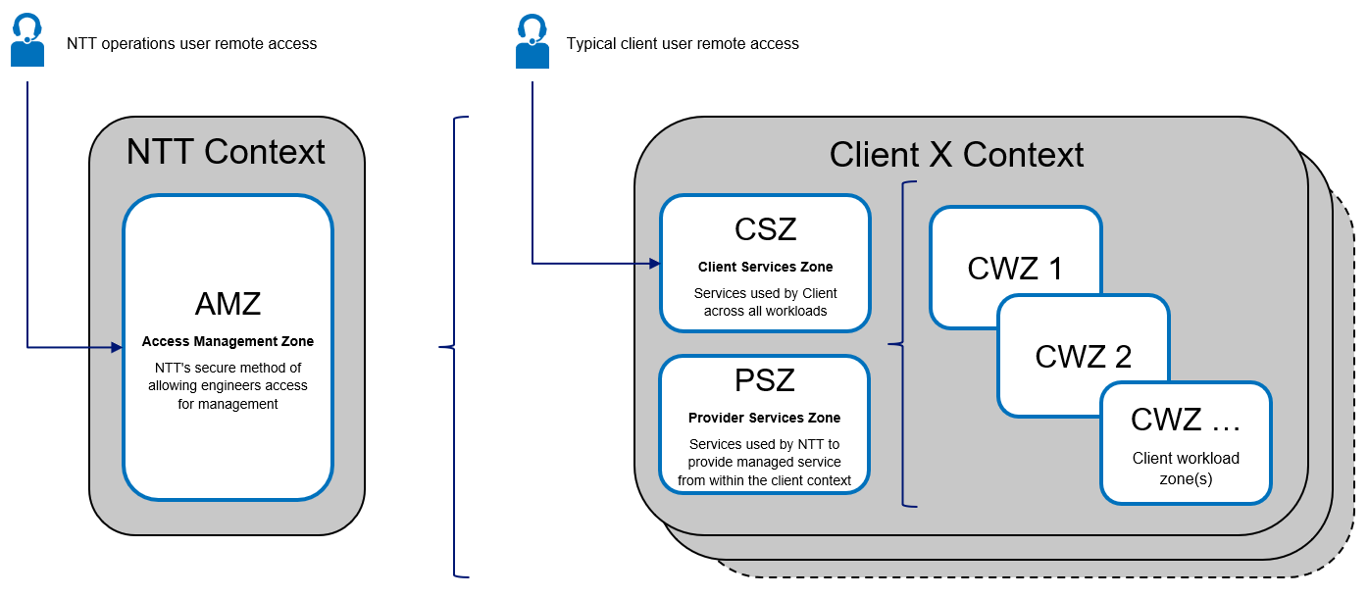

The NTT DATA Management Zone contains the services needed to centrally manage XXXX solution. Client services do not have access to this landing.
Cost of the licenses are included in the managed services costs. Resources (CPU/RAM/Storage) are paid by the client for those services running within the client solution.
NTT DATA Management Zone delivers the following functionality:
- Automation – Automation services are packaged into Docker containers. This enables the following:
  - Automated deployment of OS.
  - CMDB enrichment.
  - Automated patching.
  - Compliance as a Service (CaaS).
- Antivirus – all servers in this account will have Qualys and Crowdstrike agent installed. This is separate from client AV solution.
- Monitoring – Logic Monitor collects all monitoring and performance metrics for the solution.
- Privileged Access Management - XTAM(optional) and Linux Jump Server for non standard services or Windows VM.

NTT DATA AMZ overview
NTT DATA Access Management Zone (AMZ) refers to our solution for providing secure and traceable remote access to our customer's infrastructure. AMZ's use of multi-factor authentication (MFA) and session recording allows our operations teams, and engineers to access and manage solutions while tracking the identity and activity of each user. The AMZ is able to deliver an advanced level of governance which is critical for organizations subject to regular compliance audits (such as PCI) without compromising the agility and efficiency of support teams.

NTT DATA Shared Zones
NTT DATA Advanced Management Zone (AMZ) and Shared Management Zone (SMZ) are management platforms completely hosted in AWS and distributed in different geographical zones:
Environments | Location | Region
AMZ1, SMZ1 | Azure (West Europe) | EUROPE
AMZ2, SMZ2 | Azure (east-us) | AMERICA
AMZ3, SMZ3 | Azure (southeast-asia) | APAC

How it works
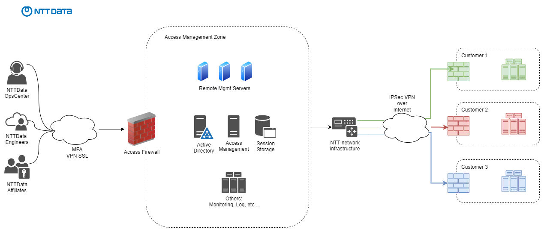

SMZ
The Shared Management Zones, (SMZ) are designated to be the platform where the different shared management tools needed by NTT DATA will be hosted. Providing and standardized tool set for all our customers, no matter geographical location, affiliate, connectivity method or scope of our engagement.
Also the SMZ firewalls are configured as VPN concentrators that allows connectivity from the AMZ to:
- NTT DATA legacy platforms
- Customer dedicated management zones
- Customer infrastructure
NTT DATA has produced the following architecture design diagram for the management technical solution.
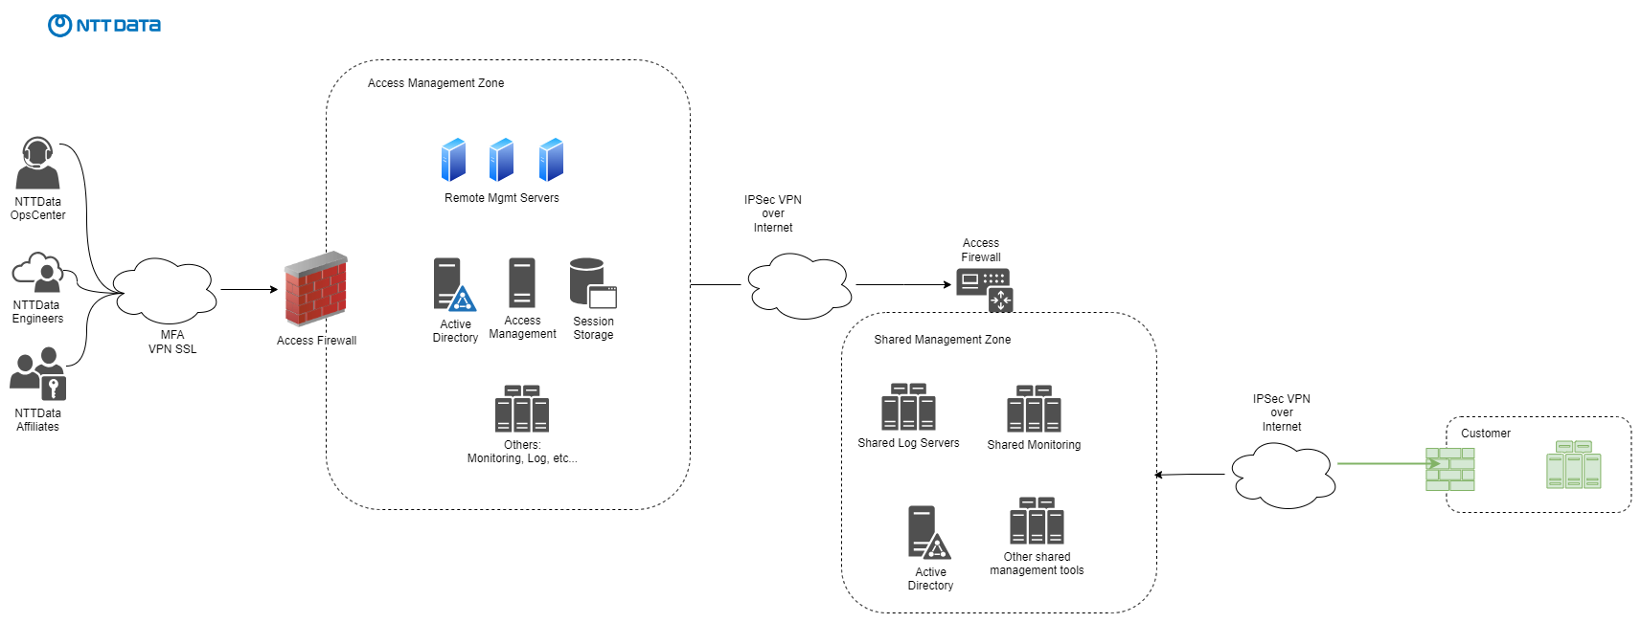

AMZ
The Access Management Zone is the NTT DATA infrastructure that is used to securely access NTT DATA customers with extra security requirements.
The AMZ is a PCI-DSS certified platform which has the security controls, including Privileged Access Management, to ensure that all access is secure and traceable. AMZ is able to deliver an advanced level of governance which is critical for organizations subject to regular compliance audits (such as PCI) without compromising the agility and efficiency of support teams.
Definitely this platform will provide NTT DATA with the possibility of providing the services in a standard approach taking advantage of the shared service model and existing operational efficiencies.

AMZ Principles
- Highly Available - Across multiple regions.
- Scalable - Accommodates many internal users, NTT DATA affiliates and contractors.
- Secure - PCI compliant enforcing unique user ID's, MFA and session recording.
- Multi-tenant - One solution that can accommodate many support teams managing multiple customers.
- Agile - Users can work efficiently, with an intuitive interface and standard tools.
NTT DATA AMZ is PCI compliant enforcing unique user ID's, MFA and session recording. The following security controls are applied from NTT DATA standard approach:
- Secure buildsHardening based on CIS benchmarks and monthly patching on all assets.
- Secure AccessRBAC SSO Terminal Server, MFA, PAM and Session recording.
- Server ProtectionNext-gen Antivirus/antimalware and Host-based IDS.
- Network protectionNetwork segmentation, Firewall IDS, Web filtering and DNS based Content filtering.
- MonitoringActive Directory account auditing, File Integrity Monitoring, Network Threat Detection, SIEM and SOC.
- VulnerabilityInternal and External vulnerability Scans, Annual internal and external penetration tests done by approved ASV and subscribed to multiple vulnerability notification feeds.
- ComplianceCompliance Scans on servers and annual ISO 20000-1, 27001 and PCI certification audits.
To satisfy customer security and compliance requirements in regards of the access to their assets, NTT DATA can provide evidence on demand off all the items below:
- PCI-DSS Attestation of Compliance report.
- ISO27001 certificate.
- Onboarding/Offboarding framework which include Policies, Process and Access Management process.
- Reports from the PAM solution covering access report, Audit Log, job summary and history, session reports.
- Session recording of an asset between any given time frame within that 1 year retention period

NTT DATA Management Zone architecture
The following architecture diagrams are produced in order to implement the new connectivity model and management zone.
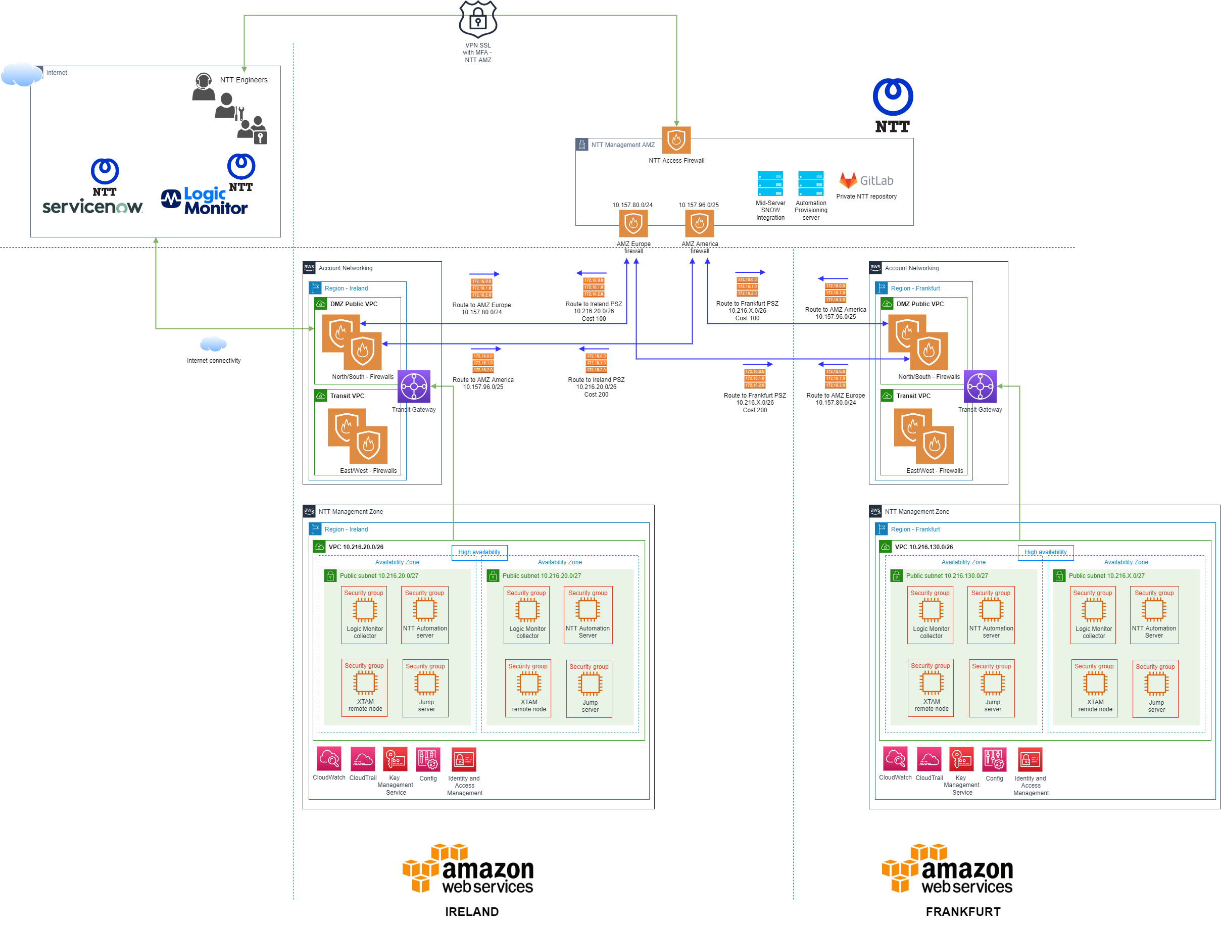

Networking design
- Dedicated AWS account for NTT DATA management resources and tools.
- Single VPC.
- At least 1 subnet hosting NTT DATA management tools which will include but not be limited to:
  - Logic Monitor - Windows VM.
  - Automation Server - Linux VM.
  - Remote Access - XTAM(preferred) and Jump Server for non standard services.
- If high availability on the management tools is required an additional subnet on a different availability zone will be configured.
- VPC connected to central Transit Gateway.
- Use a dedicated small subnet (/28) for the Transit Gateway VPC attachment.
  - If multiple availability zones are used create one "attachment" subnet per AZ.
- Access from AMZ via IPsec VPN tunnel terminated on the Transit Gateway.
- Transit Gateway route tables will allow routing of traffic between the IPsec VPN, and the NTT DATA Management Zone VPC.
- NTT DATA Management Zone VPC CIDR assigned: 10.216.X.0/26
Because of the time constraints, the following connectivity options are available in order to operate the platform from NTT DATA side.

Management VPN
NTT DATA needs to connect the NTT DATA AMZ to the NTT DATA Management Zone VPC in order to access the managed devices remotely.
To interconnect the AMZ firewalls to XXX, 2 redundant IPsec VPN tunnels need to be used as the standard connectivity mode.
Customer location | Primary SMZ | Backup SMZ
Europe | europe | america

VPN requirements
- VPN must be based on IPSEC site-to-site tunnels.
- VPN clients based on SSL or IPSEC are not supported.
- VPN type should be routed based.
- VPN peer must have a public fixed IP address. Dynamic IPs or dynamic DNS solutions are not supported.
- PSKs will be at least 32 characters long, containing at least 3 of the following: lower case, upper case, symbols and numbers.
- PSKs will be set to only be accepted from a specific remote peer.
- Each VPN will have its own PSK.

The below VPN parameters will be used to create the IPsec VPN as they meet the required NTT DATA security standards.

IKE Phase 1 (Main Mode) parameters
Property | Value
IKE Version | 2
Diffie-Hellman Group | Group 15
Authentication Method | Pre-Shared Key
Hash | SHA256
Encryption | AES256
SA Lifetime | 28,800 seconds

IKE Phase 2 (Quick Mode) parameters
Property | Value
Encryption & Hashing Algorithms | AES256
Hash | SHA256
SA Lifetime (Time) | 3600 seconds
Perfect Forward Secrecy (PFS) | Group 15
Mode | ESP

Current locations where IPSec tunnels can be terminated are:
Location | Public peer IP
SMZ1 Europe (Amsterdam) | 51.144.126.36
SMZ2 US (Virginia) | 13.92.128.212
SMZ3 APAC (Singapore) | 13.67.90.235
SMZ4 SA (Johansburg) | 102.133.183.22

NTT DATA Management Zone needs to have a routable IP range within the NTT DATA Management Zone or monitoring account in order to reach the management VMs as the automation server or the Logic Monitor collector and to jump to customer environment.
The IPSec site to site VPN will end at the customer firewalls and will be routed directly to the NTT DATA Management Zone VPC through the central Transit Gateway.
Customer has already provided the Management Zone IP range so two subnets will be used as follow to provide high availability:
- 10.216.X.0/27
- 10.216.X.32/27

This IP range (10.216.X.0/26 summarized) will be directly reachable from the NTT DATA AMZ through the established VPN. NTT DATA engineers and central services and systems will reach customer infrastructure through the components within the monitoring account or NTT DATA management zone.
Finally in order to get back to NTT DATA AMZ through the tunnels, 2 routes need to be created by customer networking teams pointing to the AMZ ip ranges.
Addressing summary:
PSZ | Primary SMZ | Backup SMZ
10.216.X.0/26 | 10.157.80.0/24 | 10.157.104.0/24

Connectivity requirements
Requirement | Purpose
Ports 3389 and 22 are allowed between the management VPCs and the rest of VPCs that will be managed. | RDP/SSH management.  Only SSH will be open for every VPC as there are no Windows systems at the time.
Ports TCP 135, TCP 445, TCP 24158, TCP 1024-65535 are allowed to Customer VPCs from Logic Monitor server. | LogicMonitor monitoring.  For every workload, NTT DATA will request the required ports to monitor the solution.
Ports 4505 and 4506. | Salt for configuration management.
5986, 5985, 22 | Ansible for configuration management.

Requirement | Purpose | Status
NTT DATA Linux users must have root privileges in all servers. Implicitly these permissions grant access to login by SSH. | Management of Servers | To be approved by customer.
NTT DATA must have a user account for Linux monitoring (nttrmmon).  - SSH keypair authentication configured.  - No password/account expiration. | LogicMonitor | To be approved by customer.
NTT DATA must have a user account for monitoring (nttsnmp).  - No password/account expiration.  - Read-only SNMP privileges. | LogicMonitor | To be approved by customer.
NTT DATA must have a generic user for Ansible/Salt control (svc_cfgadm).  - SSH keypair authentication configured.  - No password/account expiration.  - Root privileges. | Salt/Ansible | To be approved by customer.
NTT DATA must have access to the AWS accounts in the AWS Portal with PowerUser permissions. | AWS portal management | To define support and operation roles for NTT DATA managed services.
NTT DATA will use the AMZ connection to access the managed services, this process will be done with the NTT DATA’s MFA. | AWS portal management | XTAM to be approved by customer.
To access AWS administration console, NTT DATA will use the MFA. | AWS portal management | To implement AWS Single Sign On.
NTT DATA needs engineer's users to be created in the customer AD for the AWS subscriptions access. | AWS portal management | Involved engineers already in place. Access tested successfully.
NTT DATA must have permissions to install the Salt-minion (agent) in the servers under NTT DATA management. | Patching management | To be approved by customer.

Solution Assumptions
To create this technical solution, NTT DATA has made the following assumptions:
- NTT DATA will have access by Remote Desktop Protocol (RDP) and Secure Shell (SSH) to the VMs under NTT DATA management.
- The NTT DATA Management Zone VPC IP Range has been agreed between NTT DATA and customer.
- All VMs under NTT DATA management will have access to the Automation server in the NTT DATA Management Spoke using the required ports.
- NTT DATA subnets ranges (10.216.X.0/27, 10.216.X.32/27) will be properly isolated.

Performance, Capacity and Growth
The NTT DATA solution is designed around several key performance, capacity and growth principles, which are defined as follows:
- Vertical scalability: the existing VMs compute capacity can grow with additional resources (CPU, RAM, disk).
- Horizontal scalability: in case of multi-region infrastructure or disaster recovery environments, additional nodes/workers can be added to the management tools.

Security Design
AWS provides confidentiality, integrity, and availability of customer data, while also enabling transparent accountability. A full list of compliance certifications can be found at the trust center as they are constantly evolving.
https://aws.amazon.com/compliance/programs/

NTT DATA Access Management
In order to meet security requirements and be able to track user activity in customer servers NTT DATA proposes the following solutions.

PAM
Use the XTAM session recording capabilities in the NTT DATA AMZ to record, track and audit the activity of NTT DATA engineers within customer infrastructure.

Direct access
Sometimes the network design restrict direct access from NTT DATA management network and some NAT solution must be implemented.
If allowed, the following table shows the NTT DATA AMZ source IPs using private or public connectivity.
Source | Private IPs | NAT public IPs
AMZ1 Europe | 10.157.80.0/24 | 13.81.114.13 amz1nat.ntt.ms
AMZ2 USA | 10.157.96.0/24 | 40.121.64.252 amz2nat.ntt.ms
AMZ3 APAC | 10.157.104.0/24 | 137.116.143.23 amz3nat.ntt.ms
In some scenarios (public cloud, no direct access from NTT DATA infrastructure) it may be needed to access public IPs or through dedicated Bastion Hosts or Jump Servers.
Using not encrypted communications is not a best practice at NTT DATA.
NTT DATA will not be responsible of possible security issues derived of it.

Ports requirements
Typical ports required to manage the most common technologies from the AMZ (but not limited to) are:
Device | Protocol | Source | Port
Windows servers | RDP | AMZ | TCP/3389
Linux servers | SSH | AMZ | TCP/22
Network devices, Firewalls and Load Balancers | SSH, HTTP | AMZ | TCP/22, 443
Storage devices | HTTP, HTTPS, SSH | AMZ | TCP 80, 443, 22
Any | ICMP (ping) | AMZ

Multi-Factor Authentication
NTT DATA personnel will connect through Multi-factor authenticated (MFA) access mechanism, MFA is used to confirm a user's claimed identity in which a user is granted access only after successfully presenting multiple pieces of evidence.
The following diagram explains how NTT DATA employees uses Access Management Zone (AMZ) to access the customers platform in AWS.
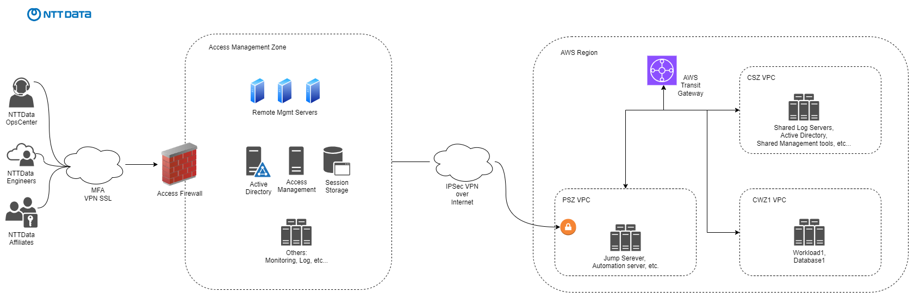

Decisions and Rationale
The following are decisions regarding Network Security.
Network security - Decisions and Rationale
Use of NACLs | NACL will be used to separate subnets from internal application subnets.
Use of SGs | Security Groups will be used as the main security control for service access.
Use of Jump server? | Yes, jump servers will be used to access non standard protocols covered by XTAM as SSH and RDP.

NTT DATA Management Tools

Logic Monitor
LogicMonitor is a SaaS (Software as a Service) monitoring solution. This means that all data storage, processing, alerting, and visualization takes place in LogicMonitor data centers and is made available to you over the portal.
The LogicMonitor SaaS-based platform is the central hub for all operations including the user interface, alert delivery, API, and integrations.
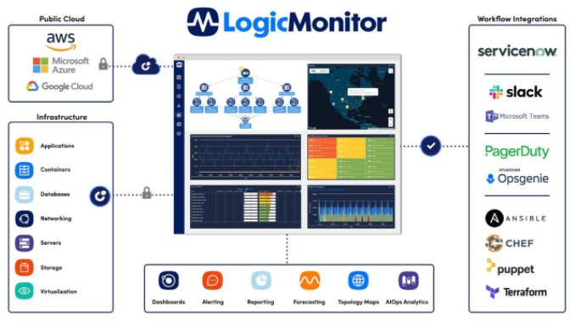

Collector deployed within NTT DATA Management Zone
In order to monitor resources for customer infrastructure, the LogicMonitor platform must have access to their performance data. Providing this access is the job of collectors.
A Collector is just a Java application running on a Windows server that communicates directly with monitored devices to gather performance metrics and then forwards the data to the LogicMonitor platform.
These are the protocols most commonly used by the Collector: SNMP, HTTP, WMI, SSH, JMX, JDBC and ICMP.
For AWS accounts and components, LogicMonitor provides the Cloud Collector which gathers performance data from cloud provider APIs.
The Cloud Collector is maintained entirely by LogicMonitor and monitors the state of the cloud accounts and the underlying services and license usage that allows you to identify faults and manage performance.
Logic Monitor specs
- No agent installation is required for the monitored devices. This is an agentless solution.
- All data reported from the collectors (cloud or installed) to LogicMonitor is transmitted securely using TLS encryption.
- In order to get the AWS account data metrics and alarms, a cross-account role with read permissions should be created to provide visibility from Logic Monitor to the monitored cloud accounts.
[https://www.logicmonitor.com/support/lm-cloud/getting-started-lm-cloud/2a-adding-aws-environment-logicmonitor]

Monitoring strategy
NTT DATA recommends to implement monitoring redundancy within LogicMonitor collectors. For dedicated collectors as in this case, it means to deploy two or more virtual machines for monitoring purposes, one as primary and the others as failover. This is only applicable to environments within a same region, for latency limitations monitoring, remote regions are not supported.
Due to the connectivity model in place X Logic Monitor collectors will be deployed in order to provide a high available and low latency monitoring services. In terms of sizing, large collectors are chosen because of the number of devices that need to be monitored. These collectors can be easily scaled up vertically and horizontally.

Network requirements
- The collector must have outgoing HTTPS access (port 443) to Internet in order to connect to the LogicMonitor cloud platform. Access can be direct or through a HTTP proxy.
- If the collector runs within the customer infrastructure or LAN, the below ports must be allowed between the collector and the devices.
- The collector is sensible to latencies and must be as close as possible to the monitored systems. In platforms distributed in different geografic regions, each region must have its own collector.
Default ports needed from the collector usually include common monitoring protocols (but not limited to), shown as follows:
Device | Protocol | Port
Windows servers | WMI | TCP/135, TCP/24158
Linux servers | SSH, SNMPv3 | TCP/22, UDP/161
Network and storage devices | SSH, SNMPv3, HTTPS | TCP/22, UDP/161, TCP/443
Any | ICMP (ping)

System requirements
- Windows OS
- Reliable NTP service
- FQDN for the server running the collector.

Permissions requirements
These are the permissions required for some of the most common technologies:
- Windows: Local administrator permissions. Using non-privileged users will limit the monitoring capabilities.
- Linux: non-privileged SSH user, SNMPv3 read-only credentials.
- Network devices: SNMPv3 read-only credentials.
- Netapp: read-only local user, SNMPv3 read-only credentials.
- Vcenter: API URL (FQDN must be resolvable from the collector).
- Vsphere hosts: local read-only user, SNMPv3 read-only credentials.
- AWS and Azure: reader role access through API.
A service account in AD for the collector is highly recommended in order to monitor multiple servers or devices joined to an Active Directory.

ProMonitor
ProMonitor will be used for monitoring SAP platform.
Like Logicmonitor a collector will be installed in the Management Zone.
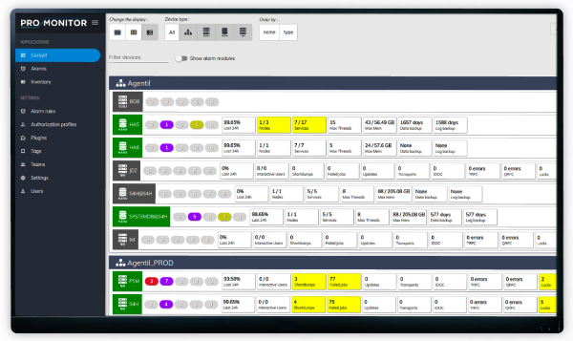

Remote ProMonitor Collector Requirements

Prerequisites
Hardware
The hardware requirements directly depends on the number of SAP systems that you want to monitor.​
SAP systems | CPU | Application Memory | Disk
<10 | 4 Cores | 6 GB | 30 GB
<50 | 4 Cores | 8 GB | 50 GB
<100 | 6 Cores | 12 GB | 100 GB
>100 | 8 Cores | 16 GB | 200 GB
​​
Software
Supported OS:
- Ubuntu server 22.04

Mandatory software:
- Java JRE v1.8 or OpenJDK 11 64 bits
- SAP JCO drivers for SAP NetWeaver systems
- SAP HANA drivers for HANA systems

Network
Network routes must be open between ProMonitor server and the monitored SAP systems. Below table indicates the standard ports to open.
SAP system type | Ports to open (defaults)
SAP NetWeaver | 36XX (Message server)  33XX (App. Server)  5XX13  5XX14  5XX00
SAP HANA | 3XX13  3XX15
SAP BusinessObjects | 64XX XX: System number  8080  8443
SYBASE | 49XX
Oracle | 15XX
DB2 | 44XX
MSSQL | 1024-5000
MaxDB | 72XX  75XX

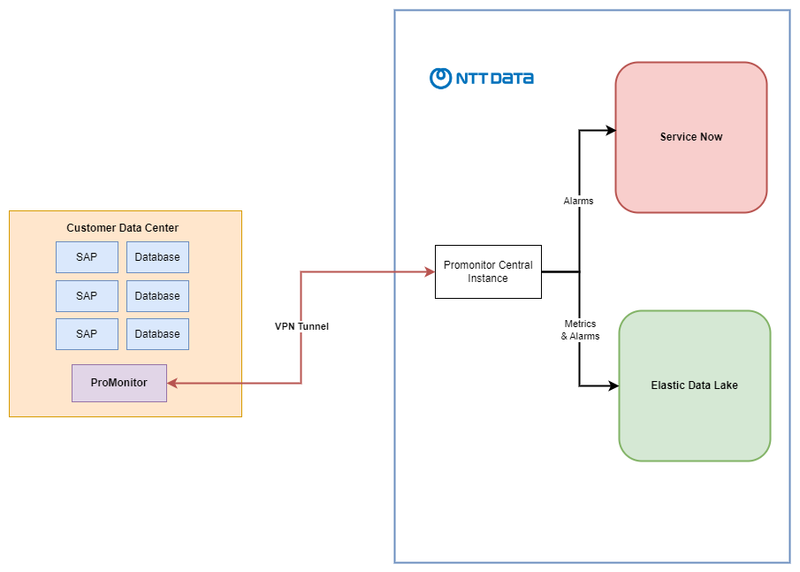

Automation

Introduction
NTT DATA Automation platform is composed by docker images that are run on a specific virtual machine "Automation Server" within the Provider Management Zone.
Customers with multiple locations where the latency is an issue, or with environment isolation requirements can be easily scaled up with more automation servers.

System and network requirements
- Ubuntu 22.04 virtual machine
- Docker host installed
- Docker host must be reachable from the NTT DATA AMZ IPs on port tcp 22.
- The destination docker host additional IP has to have a corresponding DNS entry respecting the following naming convention: salt-<customer_name>.<domain_name>.<ext>
- The destination docker host has to have a dedicated disk/partition mounted at /var/lib/docker path with a minimum of 30G
- The destination docker host hardware requirements for a single container are:
Operating System | Ubuntu 22.04
Machine Type | Virtual machine
Container Name | TBC
Hostname | TBC
IP address (PIP) | NTT-MGMT (TBC)
vCPU | 6-8
vRAM | 16 GB
Disks | 60GB, including a dedicated disk/partition mounted at /var/lib/docker path with a minimum of 30G
- The destination docker host needs port 443 access to:

  - http://nttcmsprod.azurecr.io/ (or the registry configured in your configuration file),
  - https://docs.microsoft.com/en-us/azure/azure-portal/azure-portal-safelist-urls?tabs=public-clo - Azure url's
  - https://confluence.nttltd.global.ntt/
  - https://nttcom.service-now.com (or the snow instance specified in your configuration file)
  - Packages repositories (we recommend to have a local mirror in the infrastructure if you have limited accesses or you want to control each package update)
    - Centos or Red Hat repository (extras repository is needed for 'container-selinux' package dependency)
    - https://repo.saltstack.com - saltstack repository
    - https://download.docker.com - docker repository
    - https://mirrors.fedoraproject.org - epel repository
  - Pip packages
    - https://*.readthedocs.io - various packages
    - https://github.com - several packages
    - https://pip.pypa.io/ - pip
    - https://pypi.python.org - pip
    - https://pypi.org - pip
    - https://files.pythonhosted.org - pip
    - https://requests.readthedocs.io - requests
    - https://certifiio.readthedocs.io - certifi
    - https://urllib3.readthedocs.io/ - urllib3
- If the docker host runs in a public cloud (Azure, AWS, etc), ensure that the container IP is added as a secondary IP into the NIC from the cloud, so we ensure that will not be assigned by the cloud to other VMs.
- If the docker host is behind a proxy it will be necessary to configure the proxy variables in the host:
[root@dockerhost ~]# cat /etc/profile.d/http_proxy.sh
export https_proxy=http://x.x.x.x:3128/
export http_proxy=http://x.x.x.x:3128/
[root@dockerhost ~]# cat /etc/environment
https_proxy=http://x.x.x.x:3128/
http_proxy=http://x.x.x.x:3128/
Also make sure that docker daemon on the host is using the proxy too:
https://docs.docker.com/config/daemon/systemd/#httphttps-proxy
  - http_proxy: proxy to be used for http connections (ip:port)
  - https_proxy: proxy to be used for https connections (ip:port)
  - no_proxy: comma separated list of ips, names to avoid going through proxy. A common configuration for this parameter would be to avoid using proxy on localhost connections

Core Components
Both ansible and salt obtains the information (inventory or pillars) dynamically from the CMDB.

SaltStack
Saltstack is a remote execution and orchestration platform used for:
- Provide an API with a queue mechanism in place (zeroMQ) to allow linking the automation stack with ITSM.
- Enrich Service NOW CMDB for Windows and Linux Servers.
- Orchestrate Patching Execution of Windows and Linux Servers.
- To provide a response to incidents and requests directly from the Service NOW platform to provide a faster and normalized response to customer issues and requests.

Network requirements
- The Salt master communicates with the minions using an AES connection. Salt-minions must have access to the Salt-Master on ports TCP 4505 and 4506.
- Salt-api port must be reachable from NTT DATA AMZ IPs on port tcp 8000.

Permissions requirements
- Salt-minion service in Windows must run with the Local System account, or with any other account that has local Administrator permissions.
- Salt-minion process in Linux must run as root.

Ansible
Ansible is a configuration management and orchestration platform used for:
- Complete Quality Assurance of network, windows and Linux devices ensuring the devices matches NTT DATA, CIS1 and CIS2 standards.
- Systems Configuration Management.
- Manage network devices backup.
- Enrich Service NOW CMDB for Windows, Linux Servers, and networking devices.
- To provide a response to incidents and requests directly from the Service NOW platform to provide a faster and normalized response to customer issues and requests.

System requirements
- Powershell 3.0 must be installed and enabled in a remote Windows server.
- A WinRM listener must be enabled in a remote Windows server.

Network requirements
- Access to Linux and networking devices on port TCP 22 and 443.
- Access to Windows servers on WinRM ports TCP 5986.

Backup
General Backup Management (GBM) is the tool used to guarantee that backup jobs of multiple technologies are successfully completed on expected period and window. Backup notifications are sent via e-mail to the GBM systems hosted in the NTT DATA infrastructure.
For AWS, the default tool for backups is AWS Backup solution and the native and embedded storage backup from multiple cloud services.

Patching
Windows - WSUS
WSUS servers will be used to manage Microsoft updates, including reporting and approvals of patches.
Patching will be orchestrated by SaltStack, but al the Windows Servers will download the updates from this WSUS repositories.
Linux - Repo server
Linux repository server to centralize Linux updates from a single place, providing a reporting layer.

Accessibility
NTT DATA engineers will connect to these PCI environments in a secure way using the PAM solution. Also a jump server will be in place for non standard services.
PAM
Privileged Access Management solution will be used to access customer environments and services.
Xton Access Manager (XTAM) is an agentless account and password vault, session monitoring and task execution enterprise solution with the following key features:
- Privileged Account Management & Password Vault with strong password requirements, automated password rotation and “no password access” built into its core.
- Agentless solution to ease deployment and increase adoption.
- Secure, interactive remote session within your standard web browser or native SSH clients to a remote server, network device or website.
- Layered with auditing capabilities, recording (Video, Keystroke and Clipboard Recording), workflow approval and Command Control.
- Robust event tracking and reporting for all user and system activities with a retention of one year.
- Identity Vault to secure, organize and share privileged account access. Customer specific vaults and individual personal vaults.

Connectivity requirements
Direct connectivity from AMZ:
From | To | Ports / protocols | Description
NTT DATA AMZ IPs | Customer workloads | - SSH TCP 22  - RDP TCP 3389  - WinRM TCP 5986 (only for Windows local accounts rotation)  - LDAPS TCP 636 (only for Active Directory accounts rotation)  - ICMP | Ports required by the PAM master nodes for session manager and job manager.
Connectivity from dedicated PAM remote nodes:
From | To | Ports / protocols | Description
NTT DATA AMZ IPs | Customer XTAM remote nodes | - SSH TCP 22  - HTTP proxy TCP 8081  - XTAM session manager TCP 4822  - ICMP | Access from AMZ to Remote nodes, to allow SSH and ICMP for management, and XTAM session manager access from the XTAM master nodes.
Customer XTAM remote nodes | Customer workloads | - SSH TCP 22  - RDP TCP 3389  - WinRM TCP 5986 (only for Windows local accounts rotation)  - LDAPS TCP 636 (only for Active Directory accounts rotation)  - ICMP | Ports required by XTAM for session manager and job manager.
In addition a PAM remote node will require the following outgoing Internet access:
From | To | Ports / protocols | Description
XTAM remote servers | bin.xtontech.com | - HTTPS TCP 443 | XTAM setup and updates
XTAM remote servers | *.ubuntu.com | - HTTP TCP 80 | Ubuntu OS updates

Infrastructure requirements
Requirements for a PAM remote node are:
OS | CPU | RAM | Partitions
Ubuntu 20.04 LTS | 2CPU | 4Gb | 30Gb for OS  20 Gb for PAM data (/opt/xtam)

Password rotation requirements

Windows
- WinRM with HTTPS listener (port TCP 5986) enabled on all Windows servers in order to allow password rotation for local Windows accounts.
- Certificate used by WinRM should be trusted or generated by a customer CA, or alternatively using the self-signed certificate installed by the NTT DATA Postinstall with Ansible. Generating new custom self-signed certificates for each server is not supported.
- WinRM on standard port TCP 5985 must be disabled for security reasons.
- In any Windows servers a local account with local admin permissions (i.e. "nttrmadm") is needed.
- In Windows member servers joined to a domain, an Active Directory account with permissions to update passwords in the AD (i.e. Domain Admin) is required by PAM as a shadow account to rotate local accounts.
- In standalone Windows servers not joined to a Active Directory, a secondary accounts with local admin permissions is needed, (i.e. "nttrmadm2") for contingency purposes.

Active Directory
- LDAPS using a customer-provided or self-signed certificate has to be enabled on all Domain Controllers , in order to enable password rotation for Active Directory accounts.
- Two AD accounts with Domain Admin permissions have to be provided. The first (i.e. "nttrmadm" to be used as Shadow Account to rotate Windows local accounts in domain-joined servers. The second (i.e. "nttrmadm2") for contingency purposes.

Linux
- In servers joined to an AD or LDAP, a local account with local admin permissions (i.e. "nttrmadm") is needed.
- In standalone servers, additionally a secondary local account with admin permissions is needed, (i.e. "nttrmadm2") for contingency purposes.
- If sudo access is enabled, it is required to configure sudo not to ask for the password for the SSH credentials managed from XTAM. Example of sudo configuration:
nttrmadm ALL=(ALL) NOPASSWD: ALL

Network devices and other appliances
- In devices joined to an AD or LDAP, a local account with local admin permissions (i.e. "nttrmadm") is needed.
- In devices not joined, additionally a secondary local account with admin permissions is needed, (i.e. "nttrmadm2") for contingency purposes.
- In Cisco devices with enable password configured, the enable password has to be provided.

Terraform & packer
Terraform is the system to deploy and maintain the infrastructure of cloud resources using Infrastructure as Code mechanisms. These are the main advantages:
- Infrastructure as codeInfrastructure as code manages and provisions components via definition files. Terraform allows to build, change, and version infrastructure using code techniques.
- Automated infrastructure managementTerraform works with configuration files to define applications or infrastructure and store infrastructure's state to modify or update in a controlled way.
- Reduced time to provisionNTT DATA has already in place an extensive Terraform code repository from where we can take advantage thanks to the collaborative model.
- Portability and flexibilityDue to the Terraform integrations, developed code can be reused with several infrastructure provider and it is easily portable.
- Multi-cloud readyReally useful in Disaster Recovery or Hybrid environments.
- New standardTerraform has became the IaC leader of the market, supported by a huge community.
- SimplicityEasy to learn coding and elegant template language.

Following guidelines will be followed:
Terraform guidelines
- Standardized Terraform modules in order to have a common deployment approach. NTT DATA owns a repository with a large list of services already tested and implemented.
- Separate as much as possible change affectation depending on the workload.
- State files saved and locked remotely within versioned S3 and DynamoDB service into PSZ account.
NTT DATA is continuously evolving the Terraform environment due to the contribution model we currently have in place. Some of the incoming improvements:
WIP
- Global code sharing policy is in the roadmap for 2022.
- CI/CD Gitlab pipelines for deployments are WIP.

Customer workload X
Solution specification for each workload as part of the project scope.
Platform specification including information for supporting services such as backups, monitoring and patching.
The steps taken as part of NTT DATA quality acceptance (QA) for project handover to operational support.
Application release management.
Post implementation review.

Overview
Short description of the concrete workload.

Architecture

Topology diagram
Insert infrastructure diagram to understand what components have been used and how they interact together. A separate diagram can be used for each environment or only one if they are not many components.
Relationship with external entities can also be drawn on the diagram if they are part of the solution (for example direct connect with onpremise data center).

Networking design
If the network part is complex or key to understand how the infrastructure have been setup then a network diagram can be required. For example to explain how a transit gateway works.

Infrastructure
IaaS, PaaS, SaaS and every single component deployed under the project scope.
Infrastructure components: different components per environment with their main characteristics.
Software components: List the different Software components per environment with their main characteristics, version and configuration in each of the environments. Refer to any specific configuration that could have been done, for example clustering, etc.
Domain names and certificates: List all the domain names used by the different environments, digital certificates if any and the certification valid date. Specify the exact process behind certificate renewal (renewal alert before certificate EOL, etc.
3rd party integrations: Define external components and services that are used by the solution and that can affect availability, response time, etc. For example: External SaaS services, connection to onpremise services, etc.

Application
Application details and manuals.

Security

User Management
Define the type of users that will access the platform and how they will be managed (locally or federated).
Explain if specific users, roles or permission management is required inside the project that affects operation.

Accessing the platform
List the mechanisms that are used to securely access the platform. For example: VPN, SSL tunnels, Jump servers, etc.

Software security
Explain how the software installed on the platform is kept secure excluding the standard applied for patching that is explained in a specific paragraph.

Infrastructure security
Explain the security mechanisms that make the infrastructure secure, how they are maintained and by whom.

Data classification and management
Specify the classification that is applied to the data stored in the platform.
List the specific data handling mechanisms that are applied (ej; data anonymization, encryption, etc).
List the policies that have to be specifically applied for the data within the platform, for example: Retain online data during x month, make sure data is wiped after deletion, etc.
List the certification that the platform and its management has to fulfil (ex: PCI compliance, ISO27001) and how it affects data and operations of the platform.

Backup
Backup details.

Backup strategy
Workload | Environment | Component | Policy

Backup archiving
Use this section if part of the backups are to be specifically maintained for a specified period of time and what service have been configured to do so. Example: data in S3 is automatically archived to glacier after a period of 6 month.

Logging
This section specifies the management that will be applied to all the logs on all the components of the platform. For example:
Component | Log origin | Log management Policy
AWS services | Logtrail  Cloudwatch | Logtrail trails are managed by group policy and cannot be altered.  Cloudwatch logs are kept for 7 days and then archived to S3.
Frontend Web servers | Operating system  Apache access and error logs  Tomcat access and error logs | Rsyslog is configured to push logs to centralized logstash.  Filebeat is used to push middleware logs to centralized logstash.
Database server | MySQL | …

Patching
Patching details.
The following principles apply to all system patching:
- Integration and Preproduction will usually be patched before production.
- Security patches are applied on a daily basis to reduce risk.
- Standard patches are applied on a monthly basis.
- Emergency / critical patches are applied ad-hoc where required.
- NTT DATA has specified a patching time window against each workload below. Customer can request an alternative (weekday only) time window by raising a ticket.
- When systems are redundant, their patching is done with 1 hour offset between the 1st system and the 2nd one to avoid a general downtime.

Patching strategy
Workload | Environment | Component | Policy

Monitoring
Monitoring of all services/components is 24x7.
Alerts for production services/components are raised 24x7.
Alerts for non-production services/components are raised between 08:00 and 17:00 Monday to Friday UK.
NTT DATA has defined a standard set of monitors for all the services/components, such as disk space, load average and other basic health parameters.
The standard set of monitors are the following:
- Free disk space for all partitions
- Average system load
- CPU usage
- Memory usage
- I/O operations for each disk
- Network traffic
- SSH connectivity
- TCP/IP connectivity
Additional workload specific monitoring is described below:
Describe custom monit for the workload.

Quality Acceptance
As part of the project handover to operational support, NTT DATA performs a number of quality acceptance checks.
Check | Description
Monitoring  - Standard  - Process  - VIP | Monitoring is enabled, configured correctly and verified with the customer.  Include the checks tailored to each workload where required.
Access | All instances have RDP/SSH access enabled to NTT DATA.
Processes | Start-up and stop processes defined for all instances.
Tagging | Where possible all services are tagged appropriately in the NTT DATA portal.
Documentation | Each workload is documented with all the custom functions and non-standard characteristics.
Escalations | Contacts defined. RACI matrix in place.  Phone numbers, emails, time schedules.
Patching | Time/date, execution process/order, contacts for notification.
Backup | Inclusions/exclusions, how, where, when, contacts for notification.
Scaling | Any auto scaling group is correctly configured with recommended policies.
Permissions | Agreed with the client for the non-admin access.
Custom scripts | Defined, captured in a repo, tested and defined where they run from.
Security | Firewall and AWS IAM checked for recommended configuration.

Application Release (Code) Management
Describe application releases procedure and code management with the customer.
CI/CD tool automations should be documented as long as custom scripts, cronjobs and any automation in place.
Also document any release tool configured as ENZiME,

Disaster recovery
Specify If the project includes a specific process/infrastructure for disaster recovery or business continuity purpose.

Post Implementation Review
Any pending point to be developed in a near future after the project and outside of the initial scope.

